Software Requirements Specifications

<AI COMIC GENERATOR>

Project Code:

Internal Advisor:
SIR SAAD RAZZAQ
External Advisor:

Project Manager:
Dr. SAAD RAZZAQ

Project Team:
ABDULLAH AKRAM(BSCS51F22S058) TEAM LEADER
LARAIB REHMAN (BSCS51F22S077)
MUHAMMAD AHMED(BSCS51F22S085)
Submission Date:

_____________________
Project Manager’s Signature2025
Document Information

Category | Information
Customer | CS & IT, UOS
Project | <AI Comic Generator >
Document | Requirement Specifications
Document Version
Identifier
Status
Author(s) | ABDULLAH AKRAM  lARAIB REHMAN  MUHAMMAD AHMED
Approver(s)
Issue Date
Document Location
Distribution

Definition of Terms, Acronyms and Abbreviations
This section should provide the definitions of all terms, acronyms, and abbreviations required to interpret the terms used in the document properly.

Term | Description
  NLP
  Natural Language Processing
  API
  Application Programming Interface
  UI
  User Interface
  PNG/PDF
  Portable Network Graphics / Portable Document Format
  LLM
  Large Language Model
MONGO DB
  FYP
  Final Year Project
  NO SQL DATABASE

Table of Contents
1. Introduction……………………………………………………
1.1 Purpose………………………………………………………………………………………………………
1.2 Project Scope ………………………………………………………………………………….
1.3 Document Overview……………………………………………………………………..
2. Overall Description………………………………………..
2.1 Product Perspective……………………………………………………………………………………..
2.2 User Classes and Characteristics………………………………………………………………….
2.4 Operating Environment……………………………………………………………………………….
2.5 Design and Implementation Constraints………………………………………………………
2.6 Assumptions and Dependencies……………………………………………………………………
3. System Features and Functional Requirements………………………
3.1 Story Input and Scene Splitting……………………………………………………………………
3.2 Character Image Upload and Consistency……………………………………………………
3.3 Image Generation Module…………………………………………………………………………..
3.4 Speech Bubble Generation and Dialogue Placement……………………………………
3. Panel Layout and Comic Assembly………………………………………………………………
3.6 Export Functionality……………………………………………………………………………………..
3.7 User Interface and Web Application……………………………………………………………
3.8 Project Persistence and Storage…………………………………………………………………
4. Non-Functional Requirements
4.1 Performance Requirements
4.2 Reliability Requirements
4.3 Usability Requirements
4.4 Security Requirements
4.5 Maintainability Requirements
4.6 Scalability Requirements
4.7 Portability Requirements
5. System Architecture
5.1 High-Level Architecture
5.2 Component Diagram
5.3 Data Flow
6. External Interface Requirements
6.1 User Interfaces
6.2 Hardware Interfaces
6.3 Software Interfaces
6.4 Communication Interfaces
7. System Models
7.1 Use Case Diagram
7.2 Data Model
8. Acceptance Criteria
8.1 Functional Acceptance Criteria
8.2 Performance Acceptance Criteria
8.3 Usability Acceptance Criteria
9. Testing Requirements
9.1 Unit Testing
9.2 Integration Testing
9.3 User Acceptance Testing
9.4 Performance Testing
10. Project Constraints and Limitations
10.1 Technical Constraints
10.2 Budget Constraints
10.3 Time Constraints
10.4 Scope Limitations

1. Introduction
1.1 Purpose
This Software Requirements Specification (SRS) document provides a complete description of the AI Comic Generator system. It defines the functional and non-functional requirements, system architecture, interfaces, and constraints for the development team and stakeholders.
1.2 Project Scope
The AI Comic Generator is an automated system that transforms text-based stories into multi-panel comic strips with consistent character representation, dialogue placement, and professional layout formatting.
Key Features:
- Text-to-comic conversion with scene segmentation
- Character consistency across panels via image upload
- Automated speech bubble generation and placement
- Cartoon-style image generation using AI models
- Export functionality (PNG/PDF formats)
- Web-based user interface for story input and comic customization
1.3 Document Overview
This document is organized into sections covering system description, functional requirements, non-functional requirements, system architecture, interface requirements, and constraints.
2. Overall Description
2.1 Product Perspective
The AI Comic Generator is a standalone web-based application that integrates multiple AI services and image processing libraries. It serves as an end-to-end content creation tool bridging the gap between text-based storytelling and visual comic representation.
System Context:
- Integrates with external AI APIs (OpenAI, Stability AI)
- Uses Google Colab for GPU-accelerated image generation
- Employs cloud storage for generated assets
- Provides web interface accessible via modern browsers
2.2 Product Functions
The system provides the following major functions:
- Story Input and Processing
  - Accept text stories (up to 2000 words)
  - Optional character image upload for consistency
  - Parse and segment text into logical scenes/panels
- Image Generation
  - Generate cartoon-style images for each panel
  - Maintain character consistency across panels
  - Apply user-selected art styles
- Dialogue Management
  - Extract dialogue from text
  - Generate and position speech bubbles
  - Render text within bubbles with appropriate formatting
- Comic Assembly
  - Arrange panels in readable layouts
  - Apply templates (2-panel, 4-panel, 6-panel, custom)
  - Export final comic as PNG or PDF
- Project Management
  - Save work in progress
  - Retrieve and edit previous projects
  - Manage user preferences and settings
2.3 User Classes and Characteristics
Primary Users:
- Content Creators: Bloggers, social media creators needing visual content
- Educators: Teachers creating educational visual materials
- Writers: Authors visualizing story concepts and drafts
- Comic Enthusiasts: Hobbyists experimenting with comic creation
Technical Expertise: Basic to intermediate computer literacy required. No artistic or programming skills needed.
2.4 Operating Environment
- Client Side: Modern web browsers (Chrome 90+, Firefox 88+, Safari 14+, Edge 90+)
- Server Side: Linux/Windows server environment with Python 3.9+
- External Services: Internet connectivity for API access
- Database: MongoDB 5.0+ or cloud equivalent
- GPU Access: Google Colab or local CUDA-capable GPU (optional but recommended)
2.5 Design and Implementation Constraints
- Must use external APIs for image generation (API rate limits apply)
- Image generation may take 30-120 seconds per panel
- Character consistency limited to visual reference matching
- Maximum 12 panels per comic strip
- Internet connection required for image generation
- API costs must be considered for deployment
2.6 Assumptions and Dependencies
Assumptions:
- Users have stable internet connectivity
- External API services remain available and maintain current pricing
- Users understand basic comic conventions
- Generated content will be used responsibly
Dependencies:
- OpenAI API or Stability AI API availability
- Google Colab notebook accessibility
- MongoDB/cloud database service uptime
- Frontend framework library updates
- Python package ecosystem stability
3. Functional Requirements
3.1 Story Input & Scene Splitting
The system must allow users to enter a story (50–2000 words) by typing or pasting text into the input field. A live word counter shall be displayed to guide the user. The system shall analyze the story using NLP to split content into 2–12 scenes based on length and narrative flow. Scene boundaries shall be identified using quotation marks, dialogue tags, and narrative structure.
Scene detection must achieve approximately 85% accuracy through Open AI-based or rule-based algorithms.
3.2 Character Image Upload & Consistency
The system must allow users to upload up to three reference character images (JPEG, PNG, WebP formats; size 100KB–10MB). Uploaded images must be validated to ensure safe and appropriate content. The system must extract visual features to maintain character consistency across generated panels.
Generated character likeness must meet a minimum similarity level of 70%. If no image is uploaded, the system must provide a default character for visual continuity.
3.3 Image Generation Module
The system shall generate cartoon-style comic panels using APIs such as Stable Diffusion, DALL·E, or MidJourney. The system must support cartoon, manga, western comic, and cultural (e.g., Pakistani) art styles. Panels should be generated in 512×512 or 1024×1024 resolution.
The system should auto-generate AI prompts incorporating scene context and character features. Failed generations must auto-retry up to three times, with the option for manual regeneration. Previously generated images shall be cached to avoid repeating API calls. If API limits are reached, the system shall use a fallback Google Colab generation method.
3.4 Dialogue & Speech Bubble Module
The system must automatically detect and extract dialogue from each scene. Speech bubbles must be placed based on character position using heuristic rules (top, bottom, left, right). The system shall support oval, rectangular, and thought bubble shapes, with tail indications.
Dialogue fonts shall be 12–18pt with automatic line-wrapping. Users must be able to reposition and change speech bubble style manually.
3.5 Panel Layout & Comic Assembly
The system must provide 2, 4, 6, 8, and 12-panel templates in portrait and landscape format. Panels shall follow left-to-right, top-to-bottom reading order with 10–20 pixel gutters. System should offer an optional title panel for comic branding. Users must be able to preview the final comic layout.
3.6 Export & Download
Comics can be exported as PNG (up to 4K) or PDF. User may choose low, medium, or high export quality. Exported comics should remain under 10MB under normal usage. System shall generate downloadable files within 30 seconds. Users may export panels separately.
3.7 User Interface Requirements
Interface shall be clean, minimal, and user-friendly. System must display generation progress and panel thumbnails. Dropdowns should allow users to select art style and panel layout. System must support drag-and-drop image uploads. Interface must function on desktop and tablet screens.
3.8 Project Saving & Persistence

System must auto-save project state during generation. All story text, images, and metadata must be stored in MongoDB and cloud/local storage. Basic session tracking shall allow users to resume work without login. Project data must be retained for 90 days unless deleted by user.
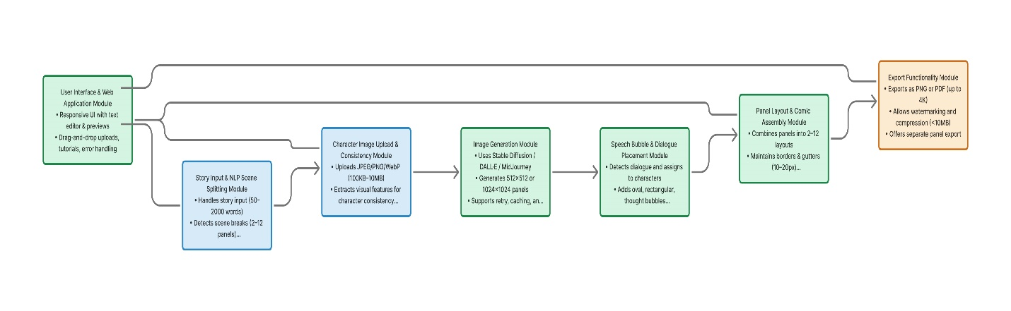
4. Non-Functional Requirements:

4.1 Performance
The system must deliver fast and efficient results. Story inputs up to 2000 words should be processed and split into scenes within 5 seconds. Each comic panel should be generated in under 2 minutes, and a full 6-panel comic must be ready within 15 minutes. The system should support up to 10 users simultaneously without performance drops, while the web interface should load within 3 seconds. Database queries must execute within 500 milliseconds.

4.2 Reliability
The system should maintain at least 95% uptime during testing and handle API errors gracefully with meaningful error messages. Failed image generations should automatically retry up to three times. To prevent data loss, an auto-save mechanism must be implemented, and all system errors should be logged for future debugging.

4.3 Usability
The platform must be user-friendly and accessible for non-technical users. A new user should be able to generate a comic within 20 minutes of first use. The interface should require no more than five clicks to start comic creation and include tooltips and navigation guidance. All prompts and error messages should be clear and understandable.

4.4 Security
Security is a top priority. All user inputs must be validated to avoid injection attacks, and uploaded images should be scanned for inappropriate content. API keys must remain confidential and never be visible on the client side. To prevent system abuse, a rate limit of 10 comics per user per hour must be enforced, and user data should remain isolated in each session.

4.5 Maintainability
The codebase should follow standard conventions—PEP 8 for Python and ESLint for JavaScript. Major functions must include docstrings and comments, and the architecture should be modular to enable easy updates or replacements. Configuration settings should be stored in external environment files, and a README file must provide setup and maintenance instructions.

4.6 Scalability
The system must support horizontal scaling of backend services to handle increased traffic. The database should be designed with future features in mind and allow easy integration with additional image generation APIs. This ensures the platform can grow without major restructuring.

4.7 Portability
The backend should run smoothly across Windows, Linux, and macOS, while the frontend must function on all modern browsers. The use of platform-independent file paths and configurations will ensure cross-platform compatibility and seamless deployment across environments.
5. System Architecture
5.1 High-Level Architecture
The system follows a three-tier architecture:
Presentation Layer (Frontend):
- React/Next.js web application
- User input forms and file upload
- Comic preview and editing interface
- Export download functionality
Application Layer (Backend):
- FastAPI/Flask REST API server
- Story parsing and scene segmentation module
- Prompt generation engine
- Image generation orchestrator
- Speech bubble renderer
- Layout and export module
Data Layer:
- MongoDB database for project storage
- File storage for generated images
- Cache layer for API responses
5.2 Component Diagram
Major Components:
- Text Processing Module
  - Story Parser
  - Scene Segmenter
  - Dialogue Extractor
- Image Generation Module
  - Prompt Generator
  - API Client (Stable Diffusion/DALL·E)
  - Colab Pipeline Connector
  - Character Consistency Manager
- Image Editing Module
  - Speech Bubble Generator
  - Text Renderer
  - Bubble Positioner
- Layout Module
  - Panel Arranger
  - Template Manager
  - Export Engine (PNG/PDF)
- Storage Module
  - Project Manager
  - Image Storage Handler
  - Database Interface
- API Gateway
  - Request Router
  - Authentication Handler
  - Rate Limiter
5.3 Data Flow
- User inputs story text and optional character image via web UI
- Frontend sends data to backend API
- Text Processing Module segments story into scenes
- Image Generation Module creates visual for each scene
- Image Editing Module adds speech bubbles
- Layout Module arranges panels
- Export Engine generates final output
- File sent to frontend for download
- Project data saved to database
6. External Interface Requirements
6.1 User Interfaces
UI-1: Main Input Screen
- Story text area (2000 character limit indicator)
- Character image upload button with drag-drop zone
- Art style dropdown selector
- Layout template selector
- Generate button
UI-2: Processing Screen
- Progress bar with status messages
- Panel-by-panel generation indicators
- Cancel operation button
UI-3: Preview and Edit Screen
- Comic strip preview
- Individual panel thumbnails
- Speech bubble editing tools
- Regenerate panel buttons
- Export options (PNG/PDF)
UI-4: Project Management Screen
- Saved projects list
- Load project functionality
- Delete project option
6.2 Hardware Interfaces
No direct hardware interfaces required. System operates through standard web protocols.
6.3 Software Interfaces
API Interfaces:
SI-1: OpenAI API (GPT & DALL·E)
- Purpose: Text processing and image generation
- Protocol: HTTPS REST API
- Data Format: JSON
- Authentication: API Key
SI-2: Stability AI API (Stable Diffusion)
- Purpose: Image generation
- Protocol: HTTPS REST API
- Data Format: JSON
- Authentication: API Key
SI-3: MongoDB Database
- Purpose: Project persistence
- Protocol: MongoDB Wire Protocol
- Data Format: BSON
SI-4: Google Colab API
- Purpose: GPU-accelerated image generation fallback
- Protocol: HTTPS
- Data Format: Notebook execution requests
6.4 Communication Interfaces
CI-1: Frontend-Backend Communication
- Protocol: HTTPS
- Format: JSON
- Methods: GET, POST, PUT, DELETE
- Port: 443 (HTTPS)
CI-2: Backend-Database Communication
- Protocol: MongoDB Protocol
- Port: 27017 (default)
7. System Models
7.1 Use Case Diagram
Actors:
- User (Content Creator, Educator, Writer, Student, Marketer)
- System Administrator
- External APIs (OpenAI, Stability AI)

Primary Use Cases:
1. Register Account
2. Login/Logout
3. Create Comic Project
4. Input Story Text
5. Upload Character Image
6. Select Art Style
7. Generate Comic
8. Preview Comic
9. Export Comic (PNG/PDF)
10. Manage Projects (View, Edit, Delete)
11. Configure Settings
12. View Generation Progress

Administrator Use Cases:
13. Monitor System Health
14. Manage User Accounts
15. View Usage Statistics
16. Configure API Settings

External API Use Cases:
17. Process Text (GPT)
18. Generate Images (Stable Diffusion/DALL-E)

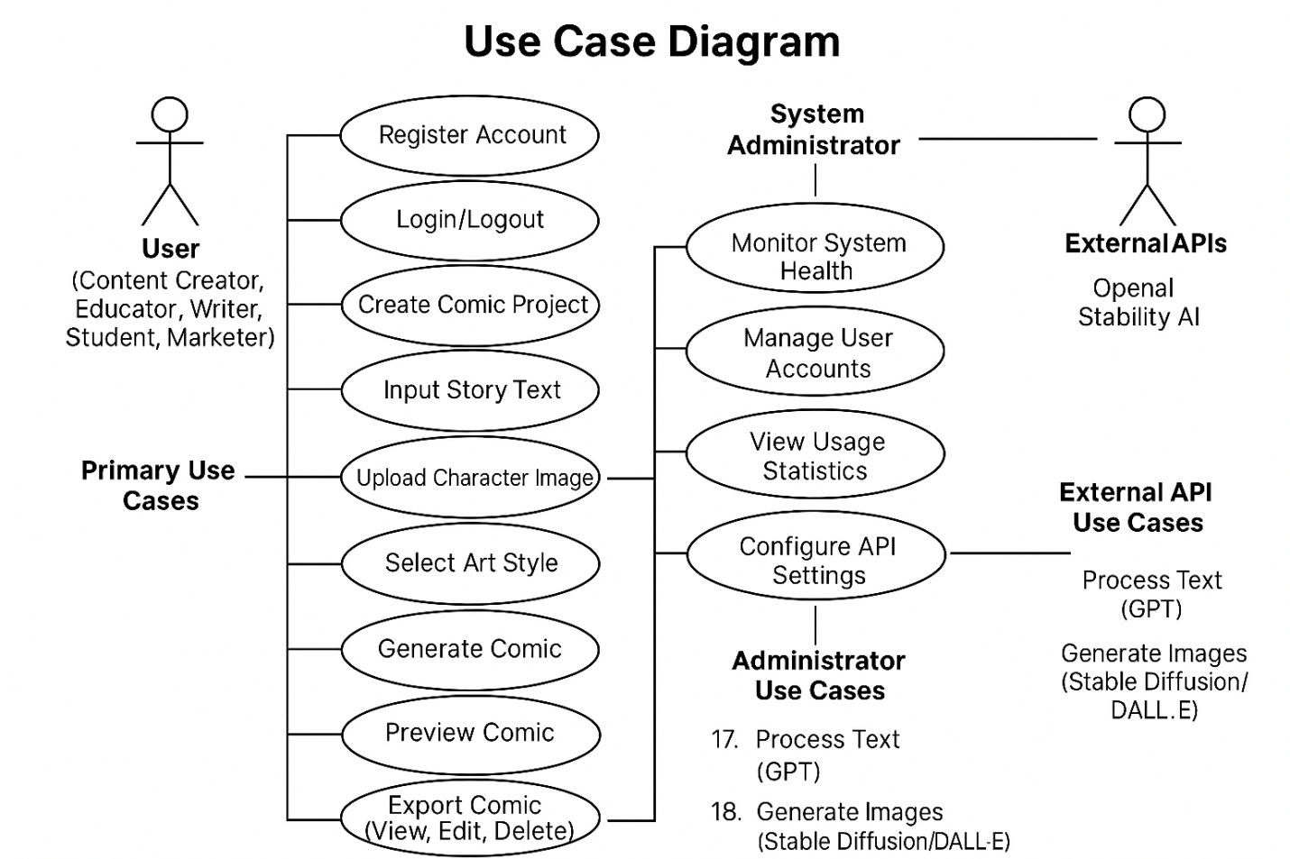
7.2 Data Model
ERD DIAGRAM
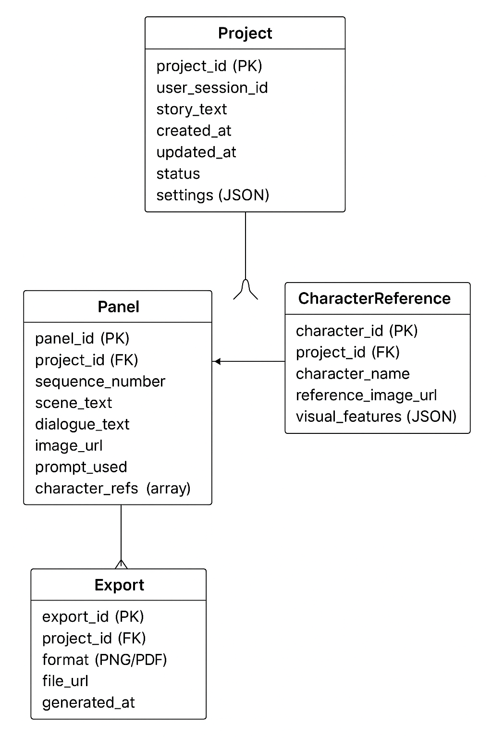
8. Acceptance Criteria
8.1 Functional Acceptance Criteria
AC-1: System successfully segments 90% of test stories into logical scenes.
AC-2: Generated images match the art style selected by user.
AC-3: Character appearance maintains 70% visual consistency across panels.
AC-4: Speech bubbles are readable and properly positioned in 85% of cases.
AC-5: Exported comics maintain resolution and layout integrity.
AC-6: Users can complete the entire workflow from input to export without errors.
8.2 Performance Acceptance Criteria
AC-7: 6-panel comic generation completes within 15 minutes.
AC-8: Web interface loads within 3 seconds.
AC-9: System handles 10 concurrent users without degradation.
8.3 Usability Acceptance Criteria
AC-10: 80% of test users successfully create a comic on first attempt.
AC-11: Users rate interface ease-of-use at 4/5 or higher.
AC-12: Users require less than 5 minutes to understand the workflow.
9. Testing Requirements
9.1 Unit Testing
- Test individual modules (scene splitter, prompt generator, bubble renderer)
- Achieve 80% code coverage
- Automated tests for API integrations
9.2 Integration Testing
- Test end-to-end workflow
- Verify API communication
- Database operations testing
9.3 User Acceptance Testing
- Conduct testing with 5-10 users
- Collect feedback on usability and output quality
- Measure success against acceptance criteria
9.4 Performance Testing
- Load testing with concurrent users
- API response time measurement
- Memory and resource usage monitoring
10. Project Constraints and Limitations
10.1 Technical Constraints
- Dependent on third-party API availability and rate limits
- GPU access required for optimal performance
- Internet connectivity mandatory
- Limited character consistency compared to fine-tuned models
10.2 Budget Constraints
- API costs may limit number of test generations
- Cloud hosting costs for deployment
10.3 Time Constraints
- 18-week development timeline
- Limited time for advanced feature implementation
10.4 Scope Limitations
- No real-time collaborative editing
- Basic character consistency only
- Limited to 12 panels per comic
- No advanced copyright management
11. Appendices
Appendix A: Glossary
- Panel: Single frame in a comic strip
- Speech Bubble: Graphical element containing character dialogue
- Scene Segmentation: Process of dividing story into panels
- Character Consistency: Maintaining visual appearance across panels
- Prompt Engineering: Crafting effective text prompts for image generation
Appendix B: Change Log
- Version 1.0 (October 17, 2025): Initial SRS document
Appendix C: Approval Signatures
- Project Supervisor: ___________________
- Team Lead: ___________________
- Date: ___________________

